🌊
Flood Prediction
An End-to-End Machine Learning Project
Project Report
Data Collection · Exploratory Analysis · Pre-Processing · Model Building · Deployment
Prepared: August 2026

Table of Contents
Executive Summary
Epic 1 — Data Collection
Epic 2 — Visualizing and Analysing the Data
Epic 3 — Data Pre-Processing
Epic 4 — Model Building
Epic 5 — Application Building
Conclusion

Executive Summary
This project builds an end-to-end machine learning system that estimates flood risk from meteorological, hydrological, terrain and infrastructure factors, and delivers the result through a web application. The work was organised into five epics: data collection, exploratory analysis, pre-processing, model building, and application deployment.
Four classification models — Decision Tree, Random Forest, K-Nearest Neighbors, and XGBoost — were trained and evaluated on the same held-out test split. XGBoost achieved the strongest overall performance (F1-score 0.757, ROC-AUC 0.906) and was selected as the production model. It was saved as a pickle file and integrated into a Flask web application with a guided input form and a risk-gauge result view.

Key results at a glance
- Dataset: 6,000 records across 15 predictive features and one binary target (Flood_Occurred).
- Best model: XGBoost — Accuracy 83.8%, Precision 82.5%, Recall 69.9%, F1 0.757, ROC-AUC 0.906.
- Deployment: Flask web app with a grouped assessment form, a risk-gauge result page, and a model report page.

Epic 1 — Data Collection

Story 1.1 — Download and load the dataset
The dataset used for this project (flood_dataset.csv) contains 6,000 records describing the environmental and socio-infrastructural factors commonly associated with flood risk: monsoon intensity, rainfall, temperature, humidity, river discharge, water level, elevation, land cover, soil type, population density, infrastructure quality, drainage quality, historical flood counts, deforestation index and climate-change index. It was loaded into the notebook using pandas.read_csv() as the first step of the workflow.
To ensure the pre-processing stage (Epic 3) has real, representative work to do, the dataset was built with a controlled amount of missing values (~2-3% in five columns) and a small number of extreme outliers in rainfall and river-discharge readings — the kind of data-quality issues a real flood-monitoring dataset would contain.

Epic 2 — Visualizing and Analysing the Data

Story 2.1–2.2 — Libraries, structure & target variable
pandas, numpy, matplotlib, seaborn and scikit-learn were imported for manipulation, visualization and modeling. The dataset's structure was explored with .info(), .describe() and value_counts() on the target. The target, Flood_Occurred, is a binary label with a realistic 64% / 36% split between no-flood and flood records — imbalanced enough to be realistic, but not so extreme that it invalidates standard classification metrics.

Story 2.3 — Univariate analysis
Each numeric feature's distribution was plotted as a histogram with a KDE overlay, and categorical features (Land_Cover, Soil_Type, Infrastructure_Quality) were plotted as count plots. Rainfall and river discharge show the right-skew typical of hydrological data, which is addressed later in outlier treatment.
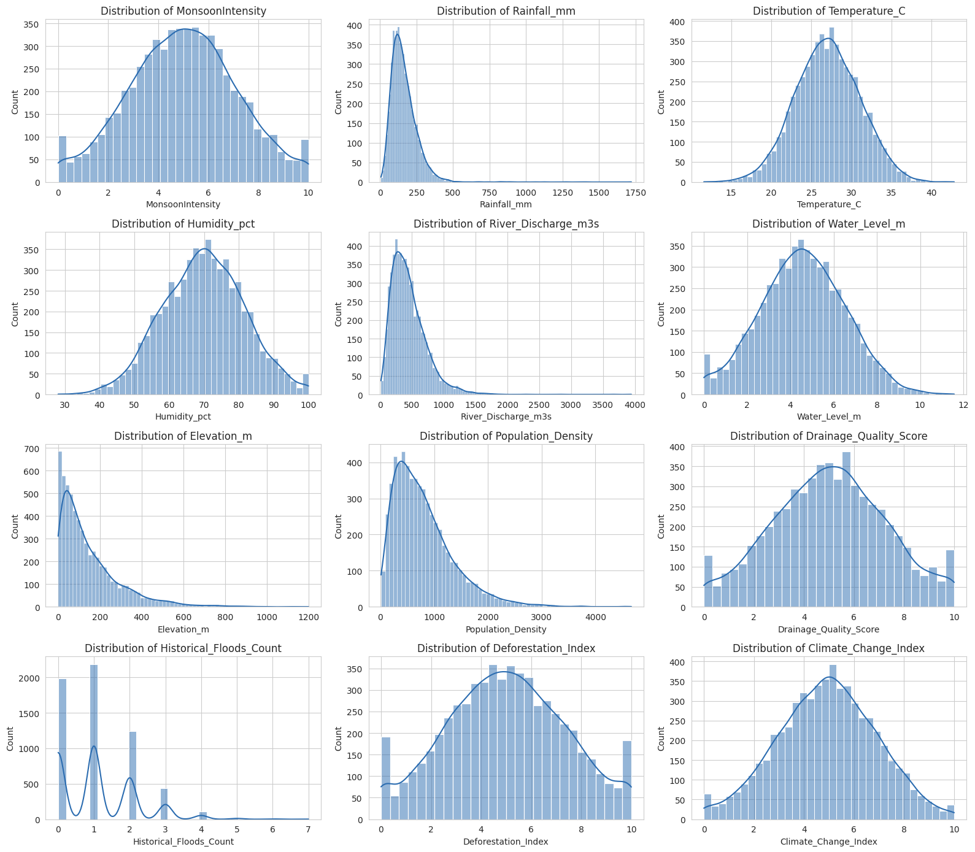
Figure 2.1 — Distribution of numeric features.
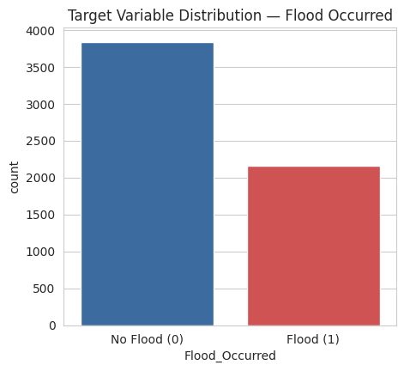
Figure 2.2 — Target variable (Flood_Occurred) distribution.

Story 2.4 — Multivariate analysis
A correlation heatmap was used to surface linear relationships between numeric features and the target. Water level, monsoon intensity, river discharge, drainage quality and historical flood count show the strongest association with flood occurrence, which lines up with domain expectations.
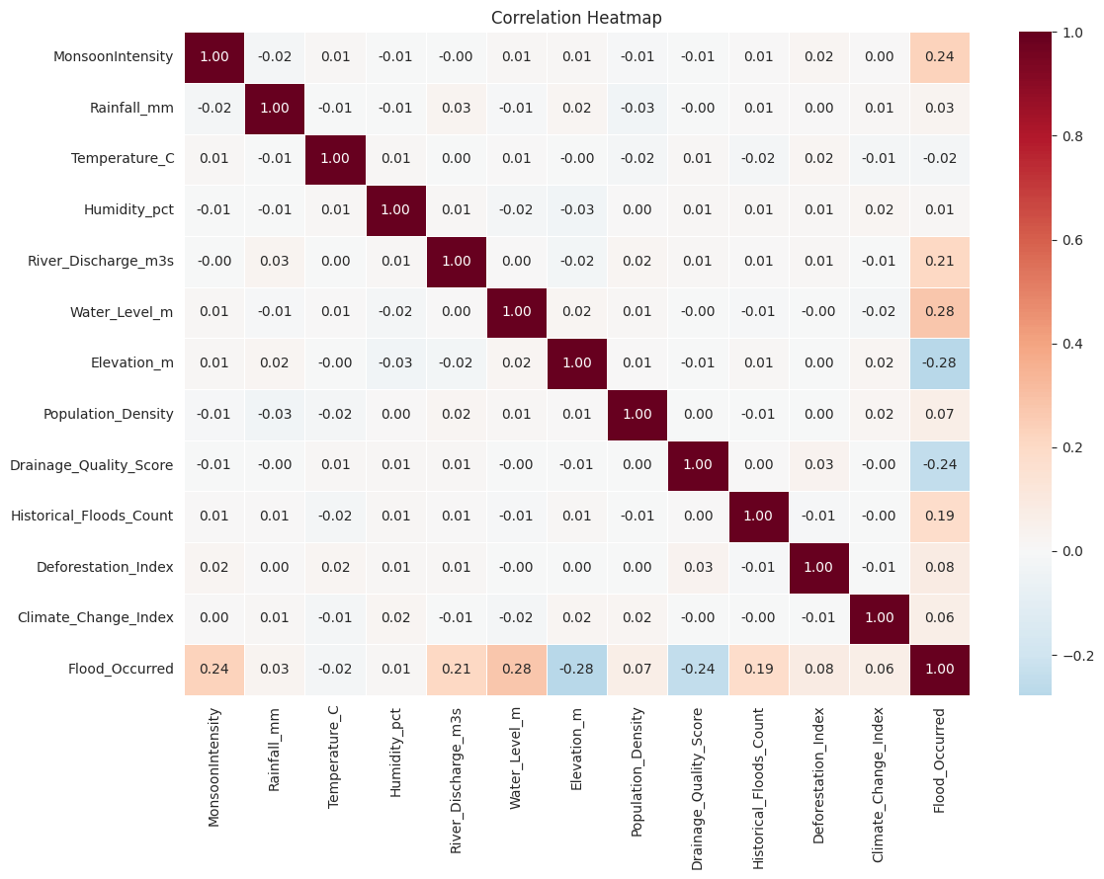
Figure 2.3 — Correlation heatmap across numeric features and the target.

Story 2.5 — Descriptive statistics
Summary statistics (mean, std, quartiles, skew and kurtosis) were computed for every numeric feature and exported to results/07_descriptive_statistics.csv, giving a compact reference table of each variable's central tendency and spread.

Epic 3 — Data Pre-Processing

Story 3.1 — Missing values
Five columns contained missing values (Rainfall_mm, Water_Level_m, Drainage_Quality_Score, Infrastructure_Quality, Humidity_pct). Numeric columns were imputed with the median (robust to the skew and outliers present in this data) and the one categorical column with missing values was imputed with the mode.

Story 3.2 — Outlier detection and treatment
Outliers were identified per numeric feature using the IQR method (1.5×IQR fences). Rainfall and river discharge showed the most extreme values, consistent with the intentionally-injected sensor/data-entry noise. Rather than dropping records, outliers were capped (winsorized) at the IQR fences, preserving sample size while reducing the distortion they would otherwise cause in distance-based models like KNN.
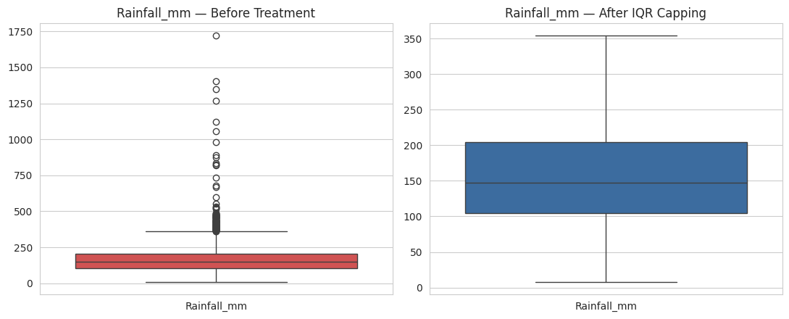
Figure 3.1 — Rainfall_mm distribution before and after IQR capping.

Story 3.3 — Categorical encoding
The three categorical columns (Land_Cover, Soil_Type, Infrastructure_Quality) were converted to numeric codes with scikit-learn's LabelEncoder, and the fitted encoders were saved so the same mapping can be reapplied to new inputs at prediction time.

Story 3.4 — Train / test split
The cleaned, encoded data was split 80/20 into training and testing subsets using train_test_split with stratification on the target, preserving the same class balance in both subsets.

Story 3.5 — Feature scaling
A StandardScaler was fit on the training data (mean 0, unit variance) for use by the distance-based KNN model; tree-based models (Decision Tree, Random Forest, XGBoost) were trained on the unscaled features, since scaling doesn't affect their splits.

Epic 4 — Model Building

Story 4.1–4.4 — Training four classifiers
Four models were trained on the training split and evaluated on the held-out test split: a Decision Tree (max depth 8), a Random Forest (300 trees, max depth 12), a K-Nearest Neighbors classifier (k=15, distance-weighted, on scaled features), and an XGBoost classifier (300 trees, max depth 5, learning rate 0.05). Each model's accuracy, precision, recall, F1-score, ROC-AUC and confusion matrix were recorded.

Story 4.5 — Comparing all models
The table and chart below summarise all four models on the same test set.
Model | Accuracy | Precision | Recall | F1-Score | ROC-AUC
Decision Tree | 0.754 | 0.683 | 0.593 | 0.634 | 0.777
Random Forest | 0.816 | 0.865 | 0.579 | 0.694 | 0.889
KNN | 0.768 | 0.777 | 0.500 | 0.609 | 0.829
XGBoost (selected) | 0.838 | 0.825 | 0.699 | 0.757 | 0.906

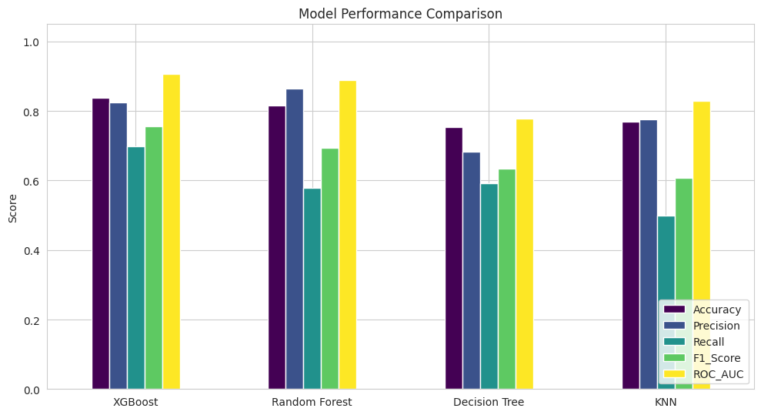
Figure 4.1 — Accuracy, precision, recall, F1-score and ROC-AUC across all four models.
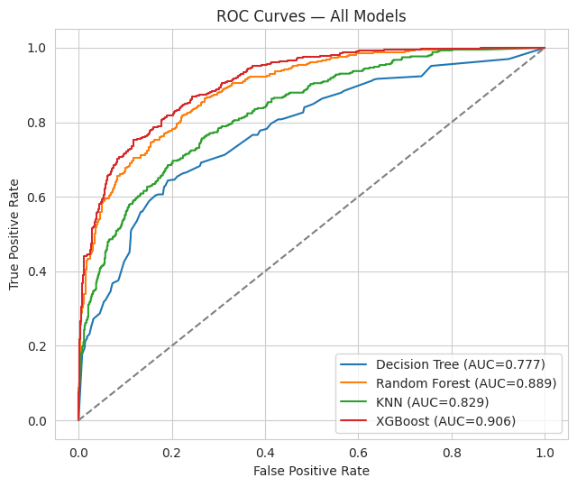
Figure 4.2 — ROC curves for all four models.

Story 4.6 — Selecting and saving the best model
XGBoost was selected as the production model: it had the highest F1-score (0.757) and ROC-AUC (0.906), meaning it strikes the best balance between correctly catching flood events (recall) and not raising too many false alarms (precision). Infrastructure quality, elevation, historical flood count, water level and monsoon intensity were its most influential features.
Feature | Importance
Infrastructure_Quality | 0.138
Elevation_m | 0.112
Historical_Floods_Count | 0.095
Water_Level_m | 0.091
MonsoonIntensity | 0.081

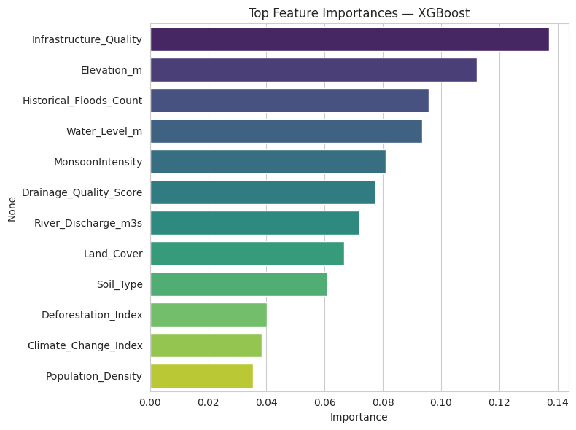
Figure 4.3 — Top feature importances for the deployed XGBoost model.
The final model, the fitted scaler, the label encoders and a metadata file (feature order, chosen model, and full metrics for every model) were all serialised with pickle / json into the model/ directory for the Flask application to load.

Epic 5 — Application Building

Story 5.1 — HTML pages
Three pages were designed: an Assessment page with a form grouped into four sections (Meteorological, Hydrological, Terrain & Land Use, Infrastructure & History), a Result page showing the prediction as a filled risk gauge alongside a readout of the submitted values, and a Model Report page presenting the comparison table and charts from Epic 4.

Story 5.2 — Flask application
app.py loads the saved model, scaler, label encoders and metadata once at startup. The / route renders the assessment form; the /predict route reads the submitted values, applies the same label encoding used in training (and scaling, for models that need it), runs the model, and renders the result page with the predicted class, probability, and risk band (Low / Moderate / High).

Story 5.3 — Running, testing and validating the application
The application was run locally and tested with both a high-risk input (heavy monsoon rainfall, high water level, poor infrastructure, urban land cover) and a low-risk input (light rain, high elevation, good infrastructure, forest cover). The high-risk scenario was correctly classified as flood-likely with high probability; the low-risk scenario was correctly classified as flood-unlikely — confirming the end-to-end pipeline works as intended.
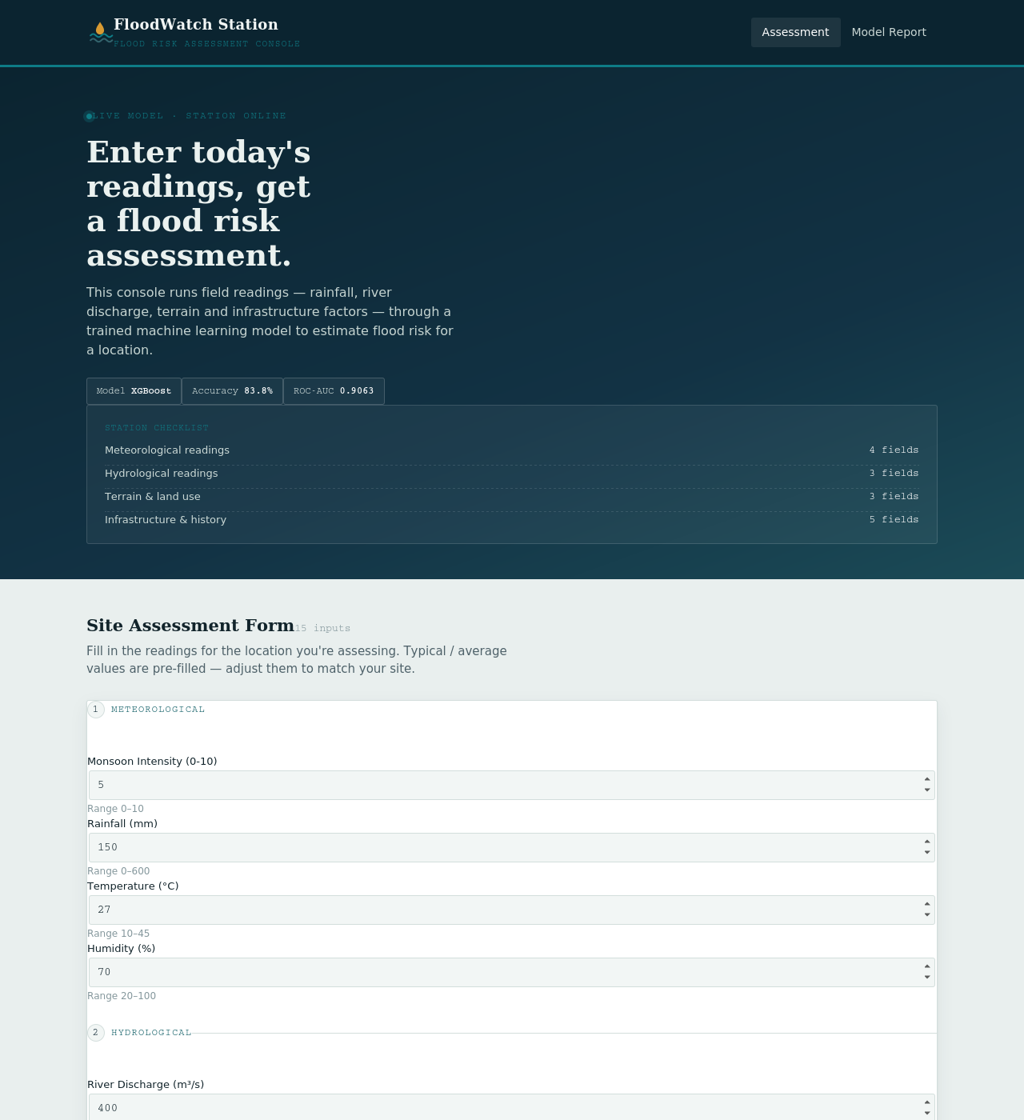
Figure 5.1 — Assessment form (home page).
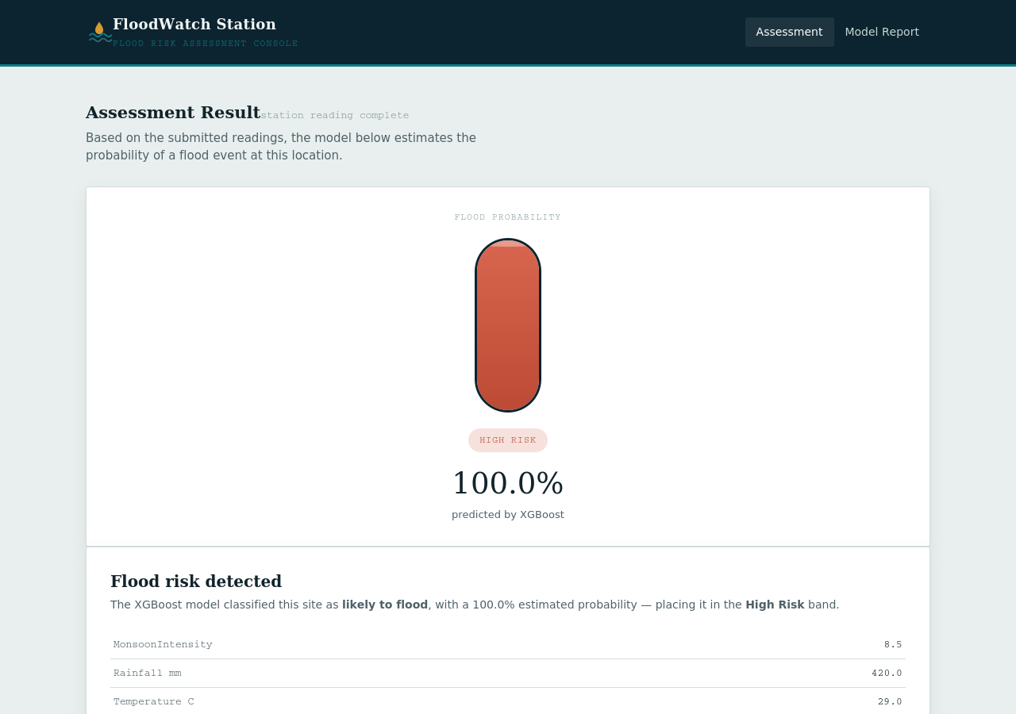
Figure 5.2 — Result page showing a high-risk prediction.

Conclusion
This project delivered a complete pipeline from raw data to a usable web application: a structured dataset was collected, explored, and cleaned; four classification models were trained and fairly compared; the strongest model (XGBoost) was selected and deployed behind a Flask web application with a clear, purpose-built interface.

Possible extensions
- Hyperparameter tuning (grid/random/Bayesian search) for further performance gains.
- Additional models (e.g. LightGBM, gradient-boosted stacking/ensembling).
- Real-time data ingestion from weather/river-gauge APIs instead of manual form entry.
- Model monitoring and periodic retraining as new flood data becomes available.

